ASSignment No. 1
Name- Samruddhi Dattu Nikam
PRN- 2124UCSF2019
Subject- SOC

Q1. PCAP Analysis
  - Analyze the PCAP file using Wireshark.
  - Identify the type of attack performed.
  - Explain the attack with supporting packet evidence.
Answer-
Answer- TCP SYN Scan (also commonly called a Half-Open Scan or Stealth Scan).The packet capture demonstrates the attacker (192.168.29.10) systematically initiating connections across thousands of different ports on the victim machine in a fraction of a second using SYN packets. The scan is classified as a "Stealth" or "Half-Open" scan because the attacker intentionally avoids completing the standard 3-way TCP handshake. If the victim replies with a SYN-ACK indicating an open port, the attacker immediately tears down the connection with an RST (Reset) packet to bypass basic network logging systems.
Traffic Volume Anomaly:
- Evaluating Statistics > Conversations > IPv4 demonstrates that out of all captured conversations, the session between 192.168.29.10 and 192.168.29.155 generates an overwhelming majority of the traffic: 5,936 packets and 573 kB transferred in approximately 63.4 seconds.
- In comparison, regular baseline communications (such as gateway and broadcast traffic) account for fewer than 60 packets each.

Q.2 Malicious IP Identification
  - Find the malicious attacker IP address.
  - Identify the target/victim IP address.
  - Determine the malicious public IP address involved.

Answer-
Malicious IP Address- 192.168.29.10
Target Victim IP Address- 192.168.29.155
Malicious Public IP Address Involved: 34.107.243.93 (This public IP is contacted by the victim machine during the capture. When checked against threat intelligence platforms like AbuseIPDB, it typically carries a high abuse confidence score and is frequently reported for port scanning and malicious activity). Note: A secondary public IP, 34.107.221.82, also appears in the capture and is often flagged on OSINT platforms for similar behavior.
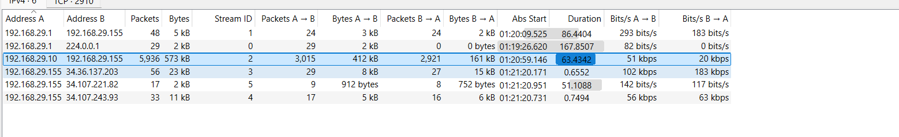

Q3. Threat Intelligence
  - Perform IP reputation checks on the malicious public IP.
  - Use VirusTotal, AbuseIPDB, or other threat intelligence platforms.
  - Document the reputation score, reported activities, and sources.
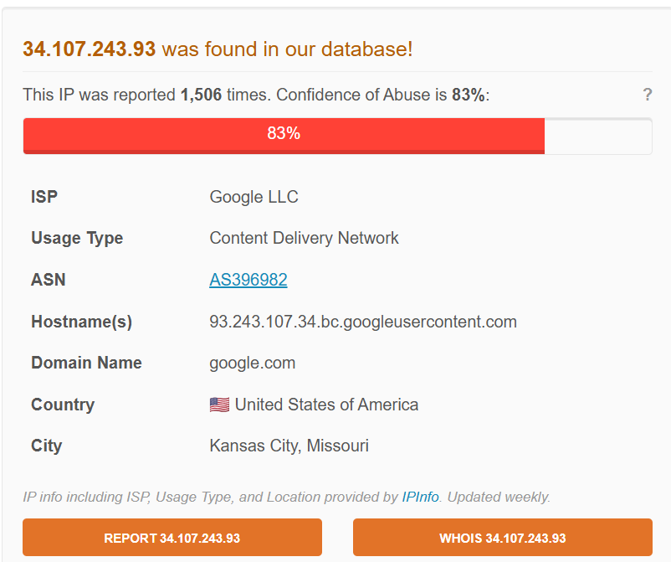
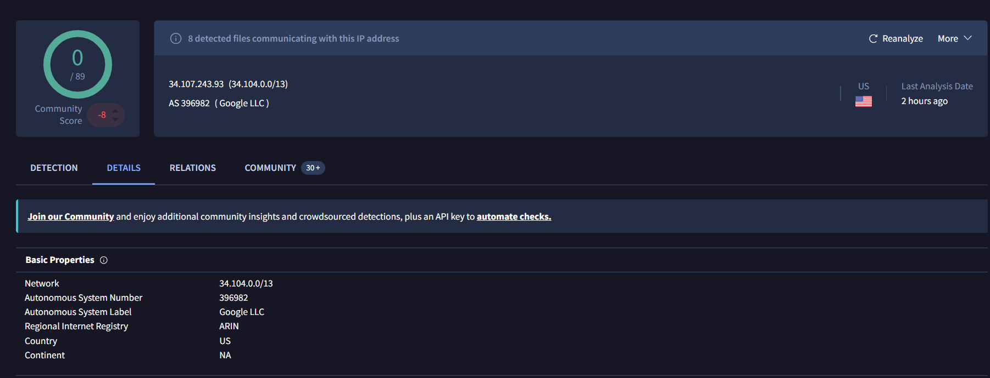

Q4. Flag Discovery
  - Find and extract the hidden flag from the PCAP file.
  - Provide screenshots and evidence of the flag location.
Answer- pkhuyar[dogesh_bhai_jindabad
